INDEX
SNO (lab) | PROGRAM | PAGE NO
Lab 1 | 1: A rocket launch system displays a countdown before launch. Instead of using a loop, implement the countdown using recursion. Write a recursive Python program to display a countdown from n to 1, followed by “launch”.  2: Banks calculate the growth of an investment using compound interest. The formula requires calculating powers. Which can be implemented recursively. Write a recursive program to calculate p^n(power), where p=principal growth factor, n= number of years  3: An HR department stores employee ID’s in a list. Develop a recursive program to search for a given employee ID. Write a recursive function to search for an employee ID in a list.  4: In a logistics company, the number of possible ways to arrange n different parcels is calculated using the factorial formula(n!). Develop a recursive program to calculate the factorial of a given number  5: Write a recursive Python program to print the first n terms of the Fibonacci series. | 3-9

LAB -1
1)AIM: A rocket launch system displays a countdown before launch. Instead of using a loop, implement the countdown using recursion. Write a recursive Python program to display a countdown from n to 1, followed by “launch”.
PROGRAM:
def launch(n):
for i in range(n,-1,-1):
if i==0:
print("launch"):
else:
print(i)
n=int (input ("enter no. of seconds to launch:"))
launch(n)
OUTPUT:
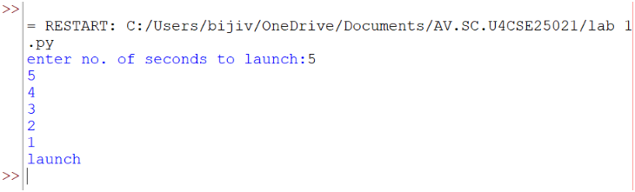
EXPLANATION:
This program displays a countdown from n to 1 and finally prints 'launch'. Although the aim mentions recursion, the given code uses a loop.

ERROR TABLE:
ERROR | CAUSE | SOLUTION
Indentation Error | Incorrect indentation | Align blocks properly
Name Error | Variable not defined | Define before use
Value Error | Non-integer input | Enter a valid integer

2)AIM: Banks calculate the growth of an investment using compound interest. The formula requires calculating powers. Which can be implemented recursively. Write a recursive program to calculate p^n(power), where p=principal growth factor, n= number of years.
PROGRAM:
def intrest(p,n):
if n==0:
return 1
else:
return p*intrest(p,n-1)
n=int(input("enter no.of years:"))
p=int(input("enter a number:"))
res=intrest(p,n)
print(res)
OUTPUT:
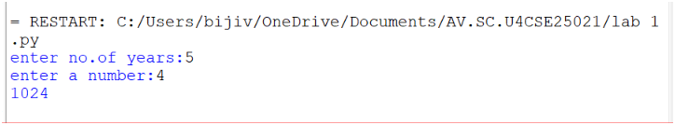

EXPLANATION:
This program recursively calculates p^n by multiplying p until n becomes 0.
ERROR TABLE:
ERROR | CAUSE | SOLUTION
Recursion error | Very large value of n | Reduce input
Name Error | Wrong function/variable name | Check spelling
Value Error | Non-integer input | Enter a valid integer

3)AIM: An HR department stores employee ID’s in a list. Develop a recursive program to search for a given employee ID. Write a recursive function to search for an employee ID in a list.
PROGRAM:
def search(m)
key=m
for i in range(n-1):
if arr[i]==key:
return i
n=int(input("enter no.of employees to add:"))
arr=[]
for i in range(n):
a=int(input("enter a value:"))
arr.append(a)
print(arr)
m=int(input("enter a element to search:"))
result=search(m)
if result==-1:
print(“element is not found”)
else:
print("employee id is stored at the index:",result)
OUTPUT:
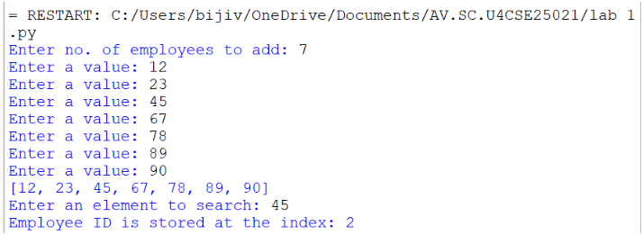
EXPLANATION:
This program searches for an employee ID in a list and returns its index if found.
ERROR TABLE:
ERROR | CAUSE | SOLUTION
Syntax error | Wrong quotes/brackets | Correct syntax
Logic error | Returns None instead of -1 | Return -1 when not found

4)AIM: In a logistics company, the number of possible ways to arrange n different parcels is calculated using the factorial formula(n!). Develop a recursive program to calculate the factorial of a given number.

PROGRAM:
def fact(n):
fact=1
for i in range(1,n+1):
fact=fact*i

return fact
n=int(input("enter a number to find its factorial:"))
result=fact(n)
print(result)
OUTPUT:
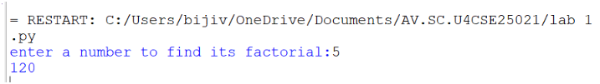

EXPLANATION:
This program calculates the factorial of a number using iteration (not recursion).
ERROR TABLE:
ERROR | CAUSE | SOLUTION
Overflow/large input | Large input value | Give smaller input
Value error | Invalid input | Even integer

5)AIM: Write a recursive Python program to print the first n terms of the Fibonacci series.

PROGRAM:
def fib(n):
if n==0:
return 0
elif n==1:
return 1
else:
return fib(n-1)+fib(n-2)

n=int(input("enter no of terms:"))
if n<=-1:
print("invalid input")
else:
for i in range(n):
print(fib(i),end=" ")
OUTPUT:
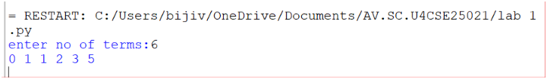
EXPLANATION:
The program uses recursion to generate Fibonacci numbers. fib (0)=0 and fib (1) =1 are the base cases. For every other term, fib(n)=fib(n-1) + fib(n-2). The loop prints the first n terms.

ERROR TABLE:
ERROR | CAUSE | SOLUTION
Recursion error | Large value of n | Use iteration
Invalid input | Negative value of n | Validate input
Slow execution | Repeated recursive calls | Use dynamic programming

PROGRAM | TIME COMPLEXITY | SPACE COMPLEXITY | REASON
1. countdown to launch | O(n) | O (1) | The program uses a loop that prints from n to 0 once.
2. Power calculation | O(n) | O(n) | One recursive call is made for each value of n—the recursion stack stores n calls.
3. Employee ID search | O(n) | O (1) | The program performs a linear search through the list.
4.Factorial | O(n) | O (1) | The program calculates factorial using a loop from 1 to n.
5. Fibonacci series | O(2ⁿ) | O(n) | Each function call creates two additional recursive calls, leading to exponential time complexity. The recursion stack reaches depth n.

